|  |
| --- |
| **Teacher: Mrs. Andersen**  **Email: nila.andersen@sd23.bc.ca**  **Website:** [**www.mrsandersensd23.weebly.com**](http://www.mrsandersensd23.weebly.com) |



**Pre-Calculus 11**

**About the Course**

Pre-Calculus 11 is designed to provide students with mathematical understandings and critical thinking skills identified for post-secondary studies involving theoretical calculus. Topics in this course include Sequences & Series, Absolute Value & Radicals, Solving Quadratic Equations, Analyzing Quadratic Functions, Graphing Inequalities & Systems of Equations, Trigonometry, Rational Expressions & Equations, and Absolute Value & Reciprocal Functions. At the end of this course, students are prepared for Pre-Calculus 12.

**Evaluation**

|  |  |  |
| --- | --- | --- |
| **Curriculum Organizer** | **Workbook Chapter** | **Percentage** |
| Algebra & Number | Unit 2 – Absolute Value & Radicals | 30% |
| Unit 7 – Rational Expressions Equations |
| Trigonometry | Unit 6 – Trigonometry | 15% |
| Relations & Functions | Unit 1 – Sequences & Series | 55% |
| Unit 3 – Solving Quadratic Equations |
| Unit 4 – Analyzing Quadratic Functions |
| Unit 5 – Graphing Inequalities & Systems of Equations |
| Unit 8 – Absolute Value & Reciprocal Functions |

The classroom mark will be a cumulative mark. Term marks on report cards will be reported as in-progress marks and will be calculated according to the following three curriculum organizers set by the ministry of education.

Final marks will be calculated using 80% of the class mark and 20% of the final exam mark. I will post marks on the wall in the classroom and email marks home after each unit.

**Web Page**

Daily homework, handouts, and information will be posted and regularly updated on my website at [www.mrsandersensd23.weebly.com](http://www.mrsandersensd23.weebly.com). Students should use the site when they miss a class to find out what they missed that day. Parents can also use the site to follow along with the class schedule and to check completion of homework. The password is:

**3.14**

**Homework**  
Homework will be assigned daily. It is **expected** that this practice will be complete and marked before the beginning of the next class. An emphasis will be made on the student's responsibility to be self-driven in their learning.

**Materials: please bring these with you each day —this is YOUR responsibility.**

* 3 ring binder, paper, and class handouts
* Pencils and eraser
* Scientific Calculator – no smartphones!
* We will be using an **OKM Pre-Calculus 11 coil bound book** instead of a textbook.

**You will be charged a fee for this coil book** and you may write in it (it is yours to keep!). If you choose to keep it in mint condition and return it at the end of the year, you will be credited the fee.

* If you would like to borrow a copy of the Pearson Pre-Calculus 11 Workbook ® that contains many more practice exercises that you can use to increase your understanding of topics beyond the given work, please see Mrs. Andersen.

**Absences**

Attendance is crucial if students expect to be successful in this class. If a student misses a class, regardless of the reason, they should expect it to have some impact on their academic achievement. If a student misses just one class, he/she will miss out on 2.5 hours of instruction. Any material that is missed due to absence or being late is the responsibility of the student.

**Classroom Conduct**

Please be courteous and respectful to your teacher, peers, and classroom equipment/supplies. Every student in the class has the right to work in a positive learning environment.

*Maintaining a work ethic of* ***G*** *is essential to success in a course like Pre-Calculus 12! Texting in class, habitual chatting off topic, and coming late, are just a few things that can affect your work ethic. This is solely based on what I see in class!*



**Cell phones should in no way interfere with learning and the operation of the school, or the safety and privacy of students and/or staff --OKM School Policy**

This course is an elective. You have elected to take it. If you choose to be on your cell phone in class, it will have a negative impact on your learning. Please use your time in class wisely. As your teacher, I would like to concentrate my time in class helping students learn.



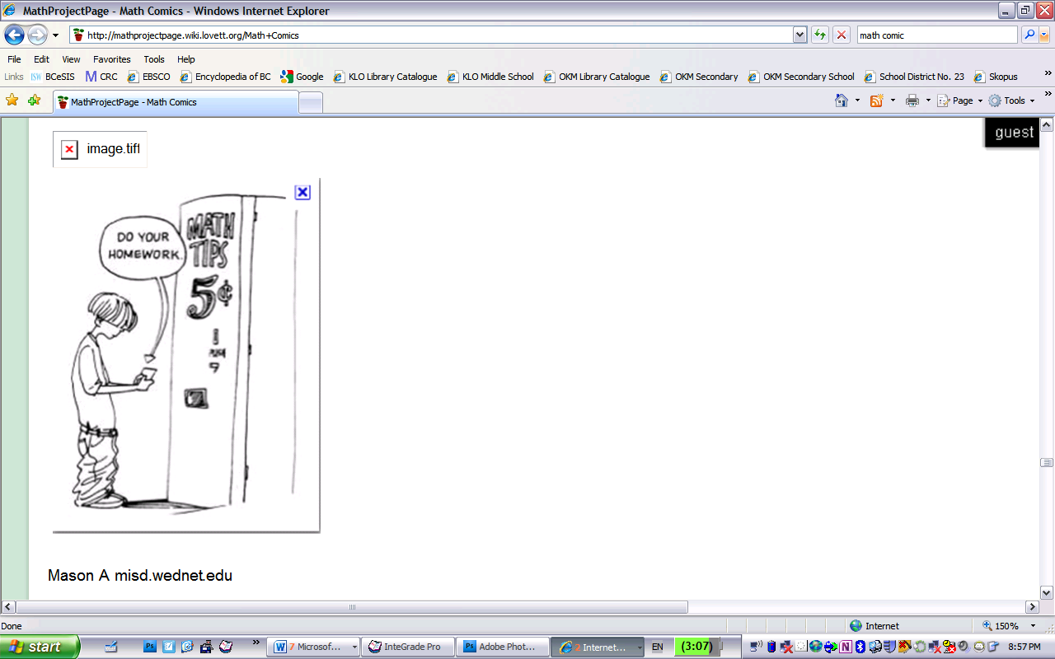We have read the course outline and have discussed its content. Note: If you provide an email address, I will email grades out at the end of each unit.

Student

Name: ______________________________________

Signed: _____________________________________

Parent/Guardian

Name(s): ____________________________________

Signed: _____________________________________

Daytime Phone Number: _____________________________

E-mail Address (Please print clearly):

_________________________________________________________

Please put any questions or concerns below, as well as any medical issues or things about your student that I should be aware of:

_________________________________________________________________________________________________________________________________________________________________________________________________________

Looking forward to a great semester!

*Mrs. Andersen*